Exploratory Data Analysis
SQL QUESTIONS & ANSWERS
Questions 1–15 | PostgreSQL

01 How many rows are in each table?
ANSWER Accounts: 42 rows • Orders: 6,912 rows • Region: 4 rows • Sales reps: 50 rows • Web events: 9,073 rows
SQL QUERY
SELECT COUNT(*) FROM accounts;
SELECT COUNT(*) FROM orders;
SELECT COUNT(*) FROM region;
SELECT COUNT(*) FROM sales_reps;
SELECT COUNT(*) FROM web_events;

02 What is the date range of orders?
ANSWER From 2013-12-04 to 2017-01-02
SQL QUERY
SELECT
MIN(occurred_at)::date AS first_order_date,
MAX(occurred_at)::date AS last_order_date
FROM orders;

03 How many of each type of paper has been sold?
ANSWER Standard : 1938346; Gloss:1013773; Poster: 723646
SQL QUERY
Select sum(orders.standard_qty) as standard_sum,sum(orders.gloss_qty) as gloss_sum,sum(orders.poster_qty) as poster_sum
From orders;

04 How much, in dollars, have each of the paper types sold?
ANSWER Standard : $ 9,672,346.54; Gloss: $7,593,159.77; Poster: $5,876,005.52
SQL QUERY
Select sum(orders.standard_amt_usd) as standard_revenue,sum(orders.gloss_amt_usd) as gloss_revenue,sum(orders.poster_amt_usd) as poster_revenue
From orders;

05 What is the most profitable paper type?
ANSWER Standard since it has highest revenue. However, profitable should be calcuated by revenue minus cost but I don’t have cost data .

06 What are the top five accounts by average total amount?
RESULT
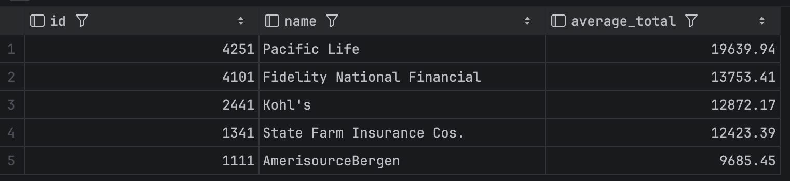
SQL QUERY
Select a.id,a.name,round(avg(o.total_amt_usd),2) as average_total
From accounts as a
Join orders as o on a.id = o.account_id
Group by a.id,a.name
Order by average_total desc
Limit 5

07 What channel do most of the online sales come from?
ANSWER Direct channel
SQL QUERY
Select
Channel, count(*) as total_events
From web_events
Group by channel
Order by total_events desc
Limit 1

08 Which region_id has the largest number of sales persons?
ANSWER Region id 1 Northeast total 21 sales persons
SQL QUERY
select r.id,r.name as region_name,count(s.id) as total_no_of_sales_rep
from sales_reps s
join region r on s.region_id = r.id
group by (r.id,r.name)
order by total_no_of_sales_rep desc
limit 1

09 Which web events channel had the highest total quantity sold of all three types of paper?
ANSWER Direct channel total 3675765
SQL QUERY
select w.channel, sum(total) as total_sold
from orders o
join (select distinct web_events.account_id,channel from web_events) w on w.account_id = o.account_id
group by channel
order by total_sold desc
limit 1

10 Which region, by name, has the highest amount of sales in USD?
ANSWER Northeast $ 7,744,405.36
SQL QUERY
select r.id,r.name as region_name,sum(o.total_amt_usd) as total_sales_usd
from accounts a
join sales_reps s on s.id = a.sales_rep_id
join region r on r.id =s.region_id
join orders o on o.account_id = a.id
group by (r.id,r.name )
order by total_sales_usd desc
limit 1

11 Categorize each region’s average sales as “Above Average” or “Below Average” based on the average for the company as a whole.
RESULT
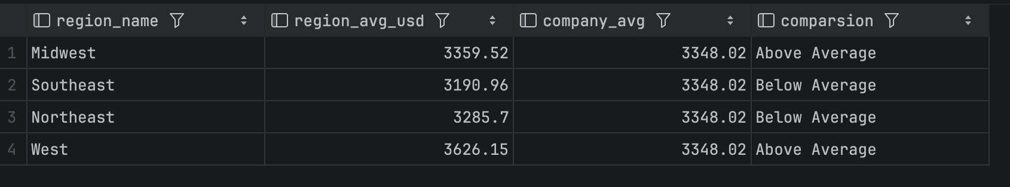
SQL QUERY
with average_region as (select r.name as region_name, round(avg(o.total_amt_usd), 2) as region_avg_usd
from accounts a
join sales_reps s on s.id = a.sales_rep_id
join region r on r.id = s.region_id
join orders o on o.account_id = a.id
group by (r.id, r.name))
select region_name,
region_avg_usd,
(select round(avg(orders.total_amt_usd),2) from orders) as company_avg,
case
when region_avg_usd > (select round(avg(total_amt_usd), 2) from orders)
then 'Above Average'
else 'Below Average'
end as Comparsion
from average_region

12 What are the total quantities of each paper type sold for the top region?
RESULT
SQL QUERY
with top_sales_region as(select r.id as region_id, r.name as region_name, round(avg(o.total_amt_usd), 2) as average_sales_as_region
from accounts a
join sales_reps s on s.id = a.sales_rep_id
join region r on r.id = s.region_id
join orders o on o.account_id = a.id
group by (r.id, r.name)
order by average_sales_as_region desc
limit 1)
select sum(o.standard_qty) as standard_qty_sum, sum(o.gloss_qty) as gloss_qty_sum,sum(o.poster_qty) as poster_qty_sum
from orders o
join accounts a on a.id =o.account_id
join sales_reps s on s.id =a.sales_rep_id
join region r on r.id = s.region_id
where region_id in (select region_id from top_sales_region)

13 What are the average sales in USD by region and sales person? Include region name, sales person’s name, and account name. Include first 20 rows
RESULT
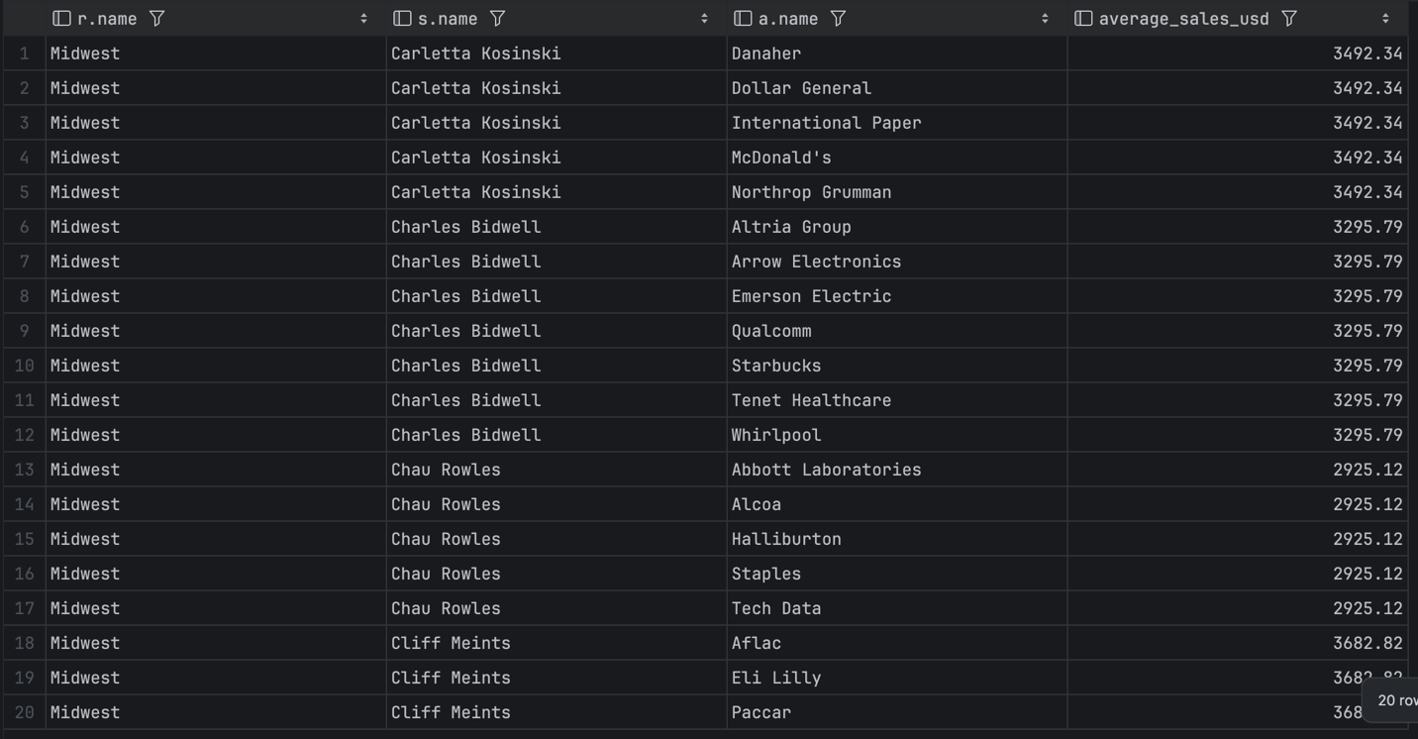
SQL QUERY
select distinct r.name,s.name,a.name,
round(avg(o.total_amt_usd) over (partition by r.name,s.name),2) as average_sales_usd
from region r
join sales_reps s on r.id=s.region_id
join accounts a on s.id =a.sales_rep_id
join orders o on o.account_id = a.id
order by r.name,s.name,a.name
limit 20

14 What is the running total of sales by month? Return the first twenty rows
ANSWER 7372719.28
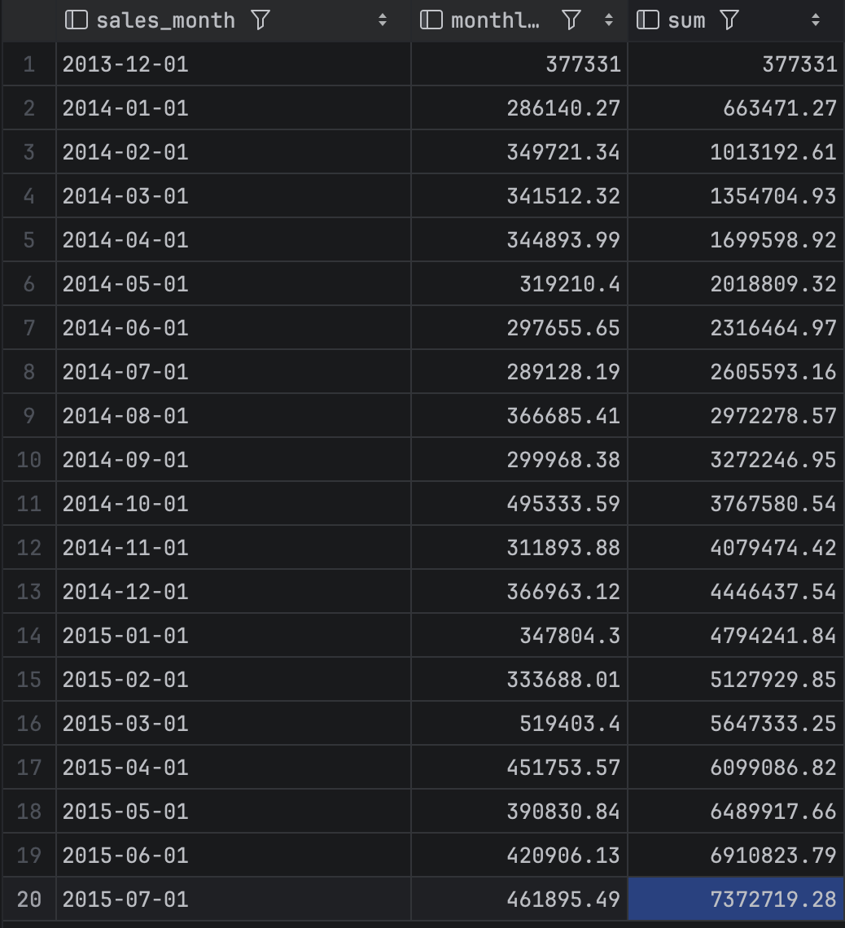
SQL QUERY
WITH monthly_sales AS (
select
date_trunc('month',occurred_at)::date as sales_month,
sum(orders.total_amt_usd) as monthly_sales_USD
from orders
group by date_trunc('month',occurred_at)::date
)
select sales_month,monthly_sales_usd,sum(monthly_sales_USD) over (order by sales_month
ROWS BETWEEN UNBOUNDED PRECEDING AND CURRENT ROW)
from monthly_sales
order by sales_month
limit 20

15 Create a seven-day moving average of orders (hint: CTE, temp table, or subquery).
ANSWER Daily order counts and their seven-day moving average.
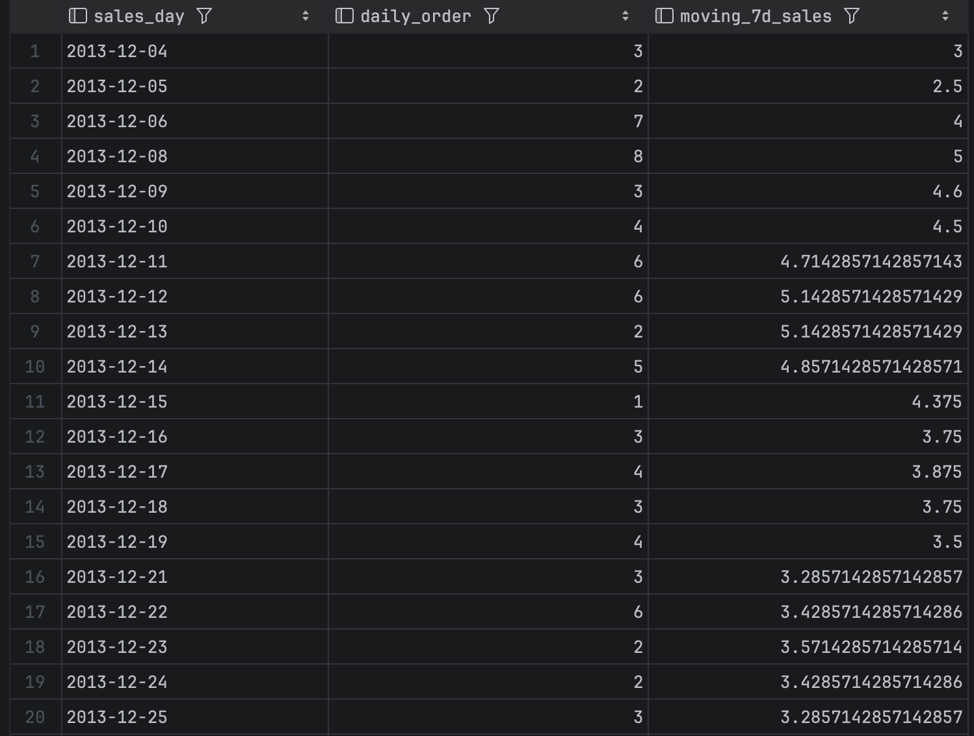
SQL QUERY
WITH daily_orders AS (
SELECT occurred_at::date AS sales_day,
COUNT(DISTINCT id) AS daily_order
FROM orders
GROUP BY occurred_at::date
)
SELECT sales_day,
daily_order,
ROUND(AVG(daily_order) OVER (
ORDER BY sales_day
ROWS BETWEEN 6 PRECEDING AND CURRENT ROW
), 2) AS moving_7d_orders
FROM daily_orders
ORDER BY sales_day;

